**OM 386 382 Marketing Analytics II**

**Assignment 2, Khyathi Balusu (kb42582)**

**Due: February 19th, 11:59pm**

**Linear and Hierarchical Linear Models: Bayesian Estimation**

In this exercise, we will practice Bayesian estimation for hierarchical linear models and regressions with random effects. We will use the same dataset "CreditCard_SOW_Data.csv" as in Assignment 1. The dataset has the following variables:

|  |  |
| --- | --- |
| ConsumerID | ID's of the sampled consumers |
| History | How long (number of months) the customer has been using the card before the experiment |
| Income | The customer's annual income |
| WalletShare | The card's share of wallet in the consumer's total monthly spending |
| Promotion | Index of monthly promotion activity –higher index indicates more pomotions |
| Balance | The customer's unpaid balance at the beginning of the month |

1). As in Assignment 1, convert consumer ID's to factors and create the following variable in the data frame: logSowRatio = log(WalletShare/(1-WalletShare)). Use the function MCMCregress() in the R package "MCMCpack" to estimate the linear regression

*logSowRatioij = β0 + β1×Historyi +β2×Incomei +β3×Balanceij +* *β4×Promotionij + εij*

Use the summary() function to find the results of the estimation. Copy and pastes the results here.

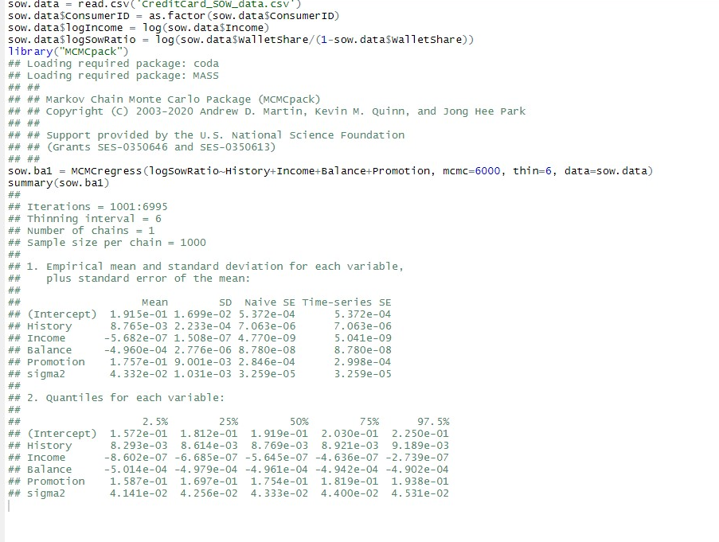

From the Bayesian posterior intervals (use 2.5% and 97.5% quantiles of the simulated posterior distributions), are regression coefficients significant at the 5% level?

The regression coefficients are significant at the 5% level as none of them include 0 in their 2.5% to 97.5% quantiles.

Use the plot() function to plot the posterior sampling chains and hist() to plot the posterior densities (histograms) for *β2* and *β3*; copy and paste the results here.

plot**(sow.ba1[,3**:**4])**

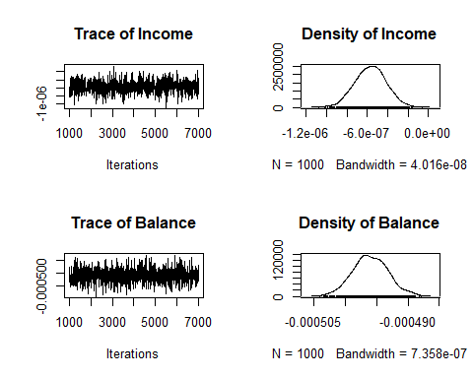

hist**(sow.ba1[,3])**

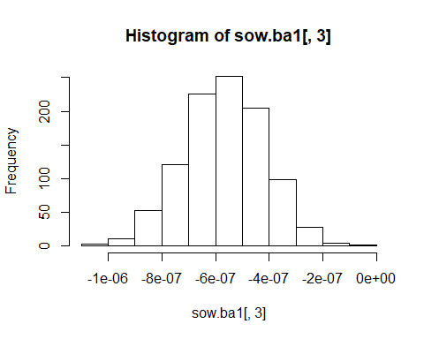

hist**(sow.ba1[,4])**

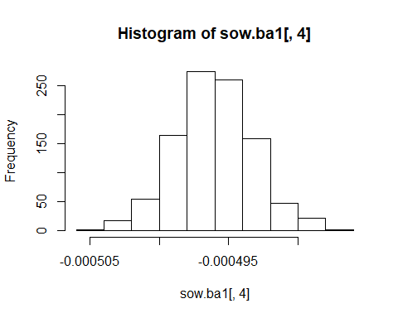

2).For the hierarchical linear model below,

*logSowRatioij = β0i + β1×Balanceij + β2i×Promotionij + εij*

*β0i = μ0 +**μ1×Historyi +ζi*

*β2i = γ0 +γ1×Historyi +**γ2×Incomei +ξi*

use the function MCMChregress( ) in the R package "MCMCpack" for its Bayesian estimation.

Please copy and paste the Bayesian estimation results of the fixed effects (same fixed effects as in (3)) in the model using summary("*yourBayesianModelName"*$mcmc[,1:6]). From the Bayesian posterior intervals, are the fixed effects significant at the 5% level?

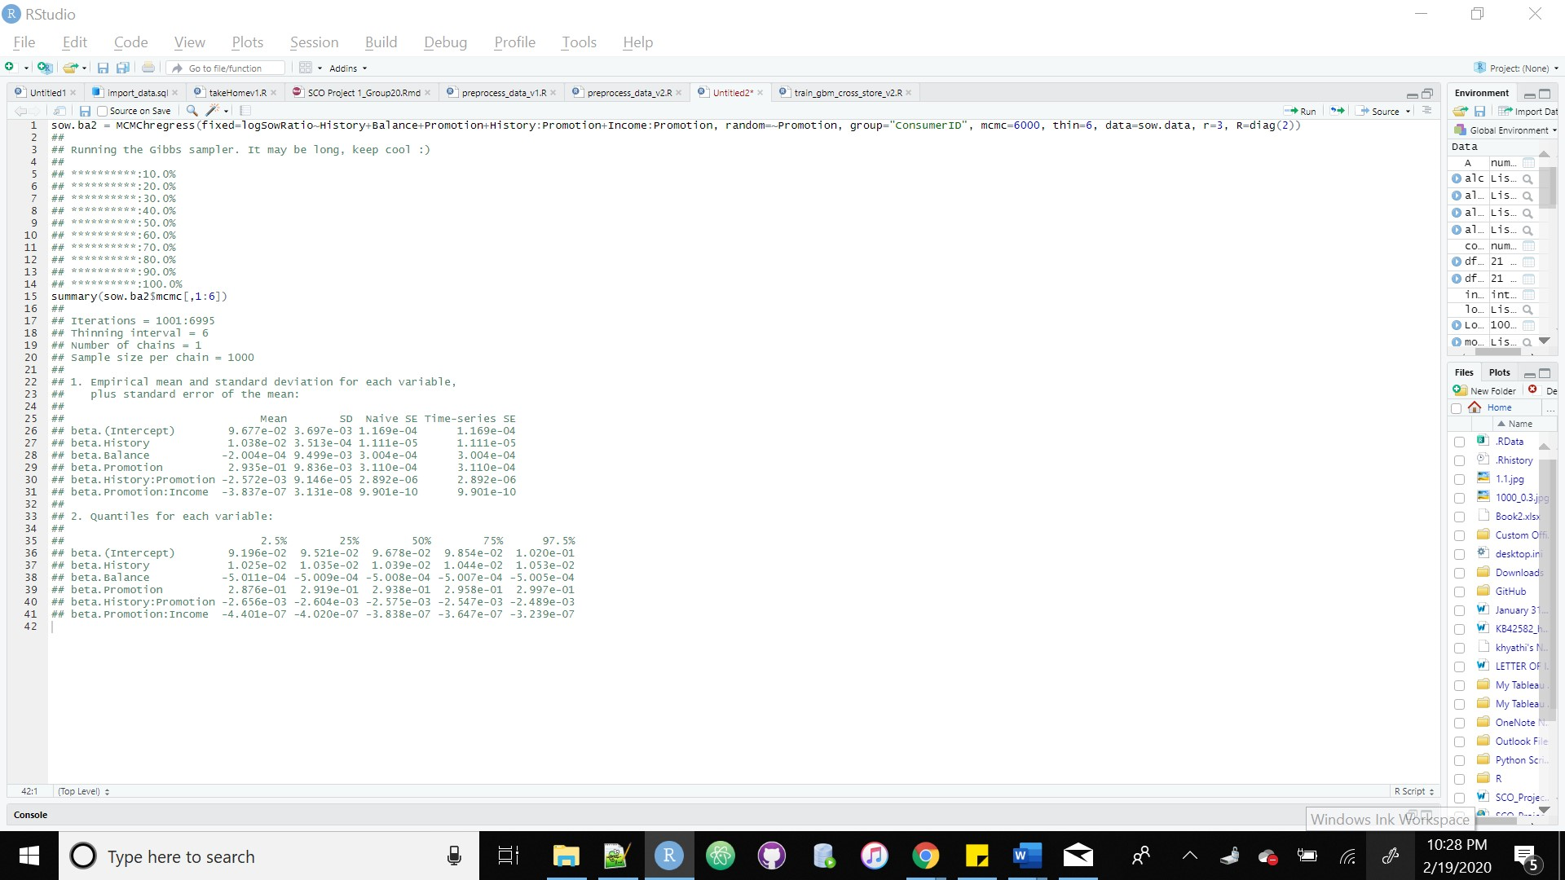

The fixed effects are significant at the 5% level as none of the variables include 0 in their quantiles.

Use the plot() and hist() function to plot the posterior sampling chains and posterior densities for *μ1* and *γ2*; copy and paste the results here.

**rows =** c**(2,6)**plot**(sow.ba2**$**mcmc[,rows])**

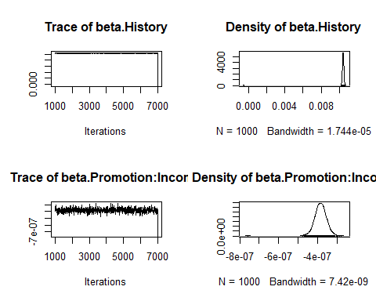

3). Next, we will fit the model in Question (1) using our own Bayesian estimation R code, which uses MCMC (Gibbs sampling) in "Assignment-2_code.r". There are a few blanks in the code. Please read the code carefully and fill in the blanks. You may use the rmnorm( ) function in the library(mnormt) to sample from multivariate normal distributions.

Please run the completed code.

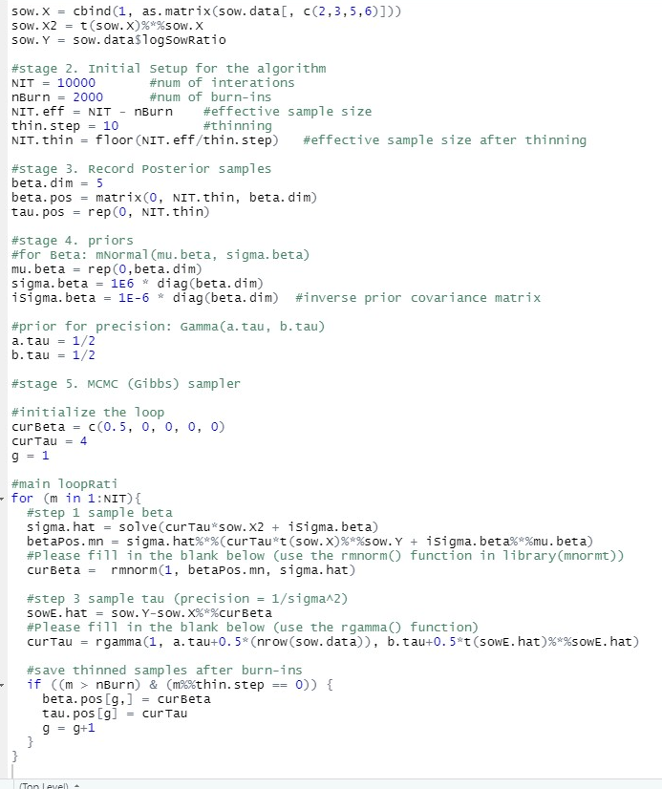

Use the plot() and hist() functions to plot the posterior sampling chains and posterior histograms for *β2, β3* and *τ .* Copy and paste the results here. Please also calculate the 95% posterior intervals for *β2, β3* and *τ.* Copy and paste the results here.

plot (beta.pos[,2], type='l')

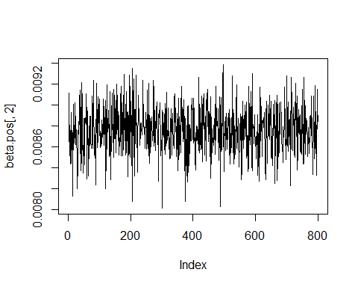

plot (beta.pos[,3], type='l')

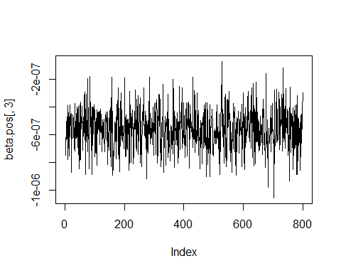

plot (tau.pos, type='l')

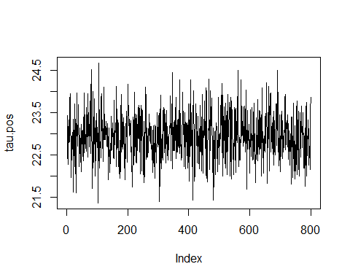

hist(beta.pos[,2])

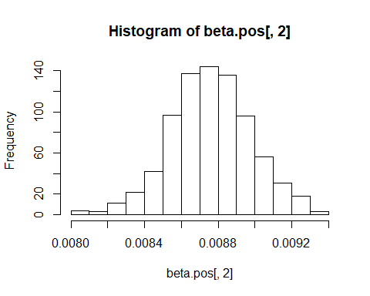

hist(beta.pos[,3])

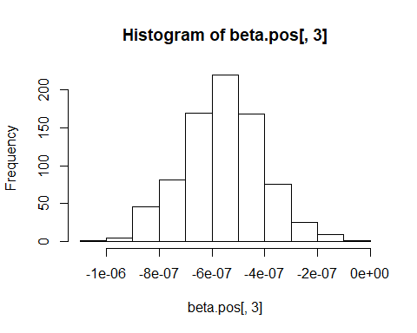

hist(tau.pos)

